Jeffrey-David Kapp 0832671 CIS2460A1 14 October 2015

1. Was completed via spreadsheet found below

Sequence = (T3, T2, T1, S2, T3, T3, S2, T2, T2 ,T1, S1, T2, S2, T2, S1, T2, T1, T3, T1)

|  |  |  |  |  |  |  |  |  |  |
| --- | --- | --- | --- | --- | --- | --- | --- | --- | --- |
|  |  |  |  |  |  |  |  |  |  |
|  | Task | Probability |  | Task | Cumulative probablity |  | **Random Numbers** | **Task** |  |
|  | T1 | 0.07 |  | T1 | 0.07 |  | 0.39587 | T3 |  |
|  | T2 | 0.31 |  | T2 | 0.38 |  | 0.25626 | T2 |  |
|  | T3 | 0.25 |  | T3 | 0.63 |  | 0.0291 | T1 |  |
|  | S1 | 0.15 |  | S1 | 0.78 |  | 0.79537 | S2 |  |
|  | S2 | 0.22 |  | S2 | 1 |  | 0.44381 | T3 |  |
|  |  |  |  |  |  |  | 0.47382 | T3 |  |
|  |  |  |  |  |  |  | 0.98622 | S2 |  |
|  |  |  |  |  |  |  | 0.37496 | T2 |  |
|  |  |  |  |  |  |  | 0.13583 | T2 |  |
|  |  |  |  |  |  |  | 0.23516 | T2 |  |
|  |  |  |  |  |  |  | 0.0478 | T1 |  |
|  |  |  |  |  |  |  | 0.64926 | S1 |  |
|  |  |  |  |  |  |  | 0.14167 | T2 |  |
|  |  |  |  |  |  |  | 0.8613 | S2 |  |
|  |  |  |  |  |  |  | 0.14739 | T2 |  |
|  |  |  |  |  |  |  | 0.65234 | S1 |  |
|  |  |  |  |  |  |  | 0.22749 | T2 |  |
|  |  |  |  |  |  |  | 0.06301 | T1 |  |
|  |  |  |  |  |  |  | 0.6024 | T3 |  |
|  |  |  |  |  |  |  | 0.03467 | T1 |  |
|  |  |  |  |  |  |  |  |  |  |

2. Was completed via spreadsheet found below.

|  |  |  |  |  |  |  |  |  |  |
| --- | --- | --- | --- | --- | --- | --- | --- | --- | --- |
|  |  |  |  |  |  |  |  |  |  |
|  | Interarrival times | Probability |  | Int. times | Cumulative probablity |  | **Random Numbers** | **Interarrival times** |  |
|  | 1 | 0.14 |  | 1 | 0.14 |  | 0.62589 | 3 |  |
|  | 2 | 0.22 |  | 2 | 0.36 |  | 0.7297 | 5 |  |
|  | 3 | 0.34 |  | 3 | 0.7 |  | 0.64817 | 3 |  |
|  | 5 | 0.23 |  | 5 | 0.93 |  | 0.55231 | 3 |  |
|  | 7 | 0.07 |  | 7 | 1 |  | 0.18171 | 2 |  |
|  |  |  |  |  |  |  | 0.05558 | 1 |  |
|  |  |  |  |  |  |  | 0.84907 | 5 |  |
|  |  |  |  | Start Time | 8:10:00 |  | 0.95678 | 7 |  |
|  |  |  |  | End Time | 9:11:00 |  | 0.37868 | 3 |  |
|  |  |  |  |  |  |  | 0.42079 | 3 |  |
|  |  |  |  |  |  |  | 0.67668 | 3 |  |
|  |  |  |  |  |  |  | 0.08061 | 1 |  |
|  |  |  |  |  |  |  | 0.05571 | 1 |  |
|  |  |  |  |  |  |  | 0.23037 | 2 |  |
|  |  |  |  |  |  |  | 0.45709 | 3 |  |
|  |  |  |  |  |  |  | 0.76553 | 5 |  |
|  |  |  |  |  |  |  | 0.48789 | 3 |  |
|  |  |  |  |  |  |  | 0.27389 | 2 |  |
|  |  |  |  |  |  |  | 0.80047 | 5 |  |
|  |  |  |  |  |  |  | 0.12426 | 1 |  |
|  |  |  |  |  |  |  | total time | 61 |  |
|  |  |  |  |  |  |  |  |  |  |

Sequence = (3, 5, 3, 3, 2, 1, 5, 7, 3, 3, 3, 1, 1, 2, 3, 5, 3, 2, 5, 1)

3.

(1*0.14)+(2*0.22)+(3*0.34)+(5*0.23)+(7*0.07)= 3.24 minutes

Arrival rate is one custom every 3.24 or ~18 customers per hours

4.

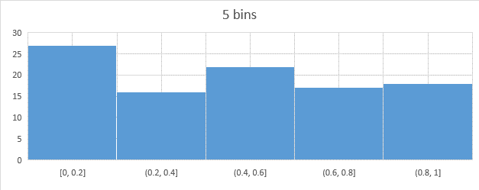

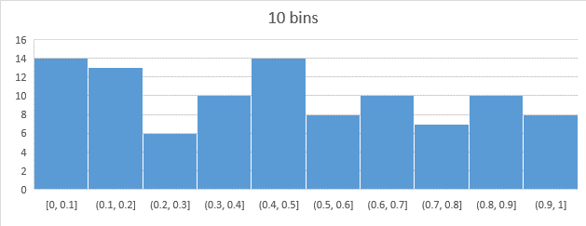

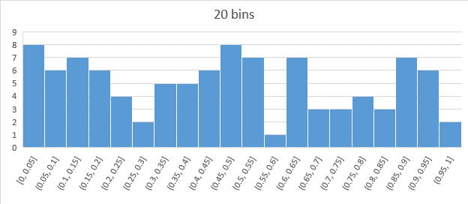

4 (continued)

d. Each histogram has peaks in similar places. The peak ranges 0-0.2 and 0.4-0.6 on the five bin graph can still be seen in the more detailed graphs. Similarly, low points, notably 0.25-0.3, 0.55-0.6 and 0.95-1 on the 20 bins and their impact on the larger bins of the 10 and 5 bin graphs can be seen.

5. Not completed